Name:- Ritesh Badhe Batch:-f Roll no:-115 Date-30/01/25 Practical no:- ll & 12 Practical name '-Study Of Operation Research in Pyton(LPP)

QI) Write a python program to display the following LPP by using pulp module and simplex method. Find its optimal solution if exist Max Z = x + 2y + z subject to x + 2y * 22 I, 3K + 2y + z 8, x Oy

# 2 0,2 2 0

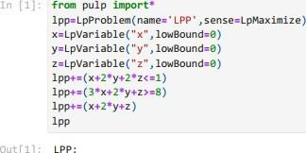

out[l

RAXIMIZE

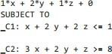

VARIABLE

S x Continuo us y Continuo us z Continuo us

# Ipp.solve()

|  |  |
| --- | --- |
| out[21  : | Ipp. objective.  value() |
| out[31  : | 2.6666667  x. value() |
| Out[41  :    out(S)  : | 2.6666667  y. value() |

Q2) Write a python program to display the following LPP by using pulp module and simplex method.

Find its optimal solution if exist Max Z = 3x + 5y * 4z subject to 2K * 3y 8 2y * Sz 10 3K + 2y +



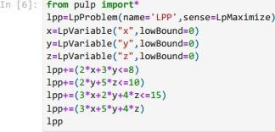

VARIABLE

S x Continuo us y Continuo us z Continuo us

# Ipp.solve()

"x" , Iowgoundza)

, Iowgoundza)

Z<z15)

out[61 : 

RAXIMIZE

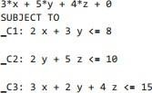

+

4*

|  |  |
| --- | --- |
| out[ll  : | Ipp. objective. value() |
| out(S)  : | 18.6585365øøøøøeø4  x. value() |
| out[gl  : | 2.17ø7317 |
| In lie) : | y. value() |
| outliel  : | 1.2195122  Q3) Write a python program to display the following LPP by using pulp module and simplex method.  Find its optimal solution if exist Max Z = 4x + y + 3z + sw subject to 4x +  20 —3x—2y *  10 -8x-3y  pulp import* |

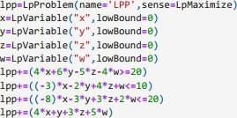

|  |  |
| --- | --- |
| outlill  : | I pp    RAXIMIZE |

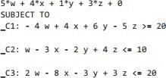

VARIABLES

 Continuous x Continuous

1. Continuous
2. Continuous

In 1121

# : Ipp.solve()

outli21 : 

|  |  |
| --- | --- |
| In 1131 :  outli31 :  In 1141 :  outli41 :  In I IS) :  outlisl  : | Ipp. objective. value()  3.3333333   1. value()      1. value()   3.3333333  Q4) Write a python program to display the following LPP by using pulp module and simplex method.  Find its optimal solution if exist Max Z = 3x + 2y * 5z  subject to x + 2y + z 430 3x * 42 460 x + |



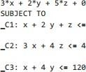In 1161 : 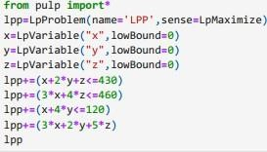

|  |  |
| --- | --- |
| outli61  : | RAXIMIZE |

43e 46B



|  |  |
| --- | --- |
| outlill  : | VARIABLES  x Continuous y Continuous z Continuous  Ipp.solve() |
| In 1181 : | Ipp. objective.  value() |
| outligl  : | 635.ø |
| In 1191 :  outligl : | x. value() |
| In 12e1 :  out12e1 : | y. value() |

Q5) Write a Python program to solve the following LPP: Min Z — x

+ y subject to X 6 y 2 6 x + y  ln 1211 :pulp import*

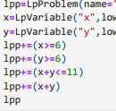LPP

out1211 : 

MINIMIZE

,sensezLpMinimize)

"x" , Iowgoundza) "y" , Iowgoundza)

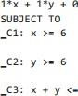 11

VARIABLE

S x Continuo us y Continuo us

|  |  |
| --- | --- |
| ln 1221  :  out1221  :    out1231  :    out1241  : | Ipp.solve()    Ipp. objective. value()    x. value() |

y. value()

out12s1 : 